**EDA Azure Inlab**

1. Uploading and choosing dataset

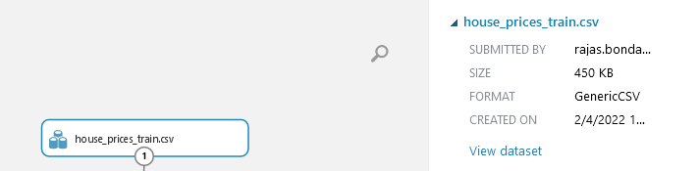

1. Selecting columns in dataset
   1. The dataset has over 72 columns. Thus only,
      1. LotArea: area of the house
      2. OverallQual: Quality of the house 1-10
      3. YearBuilt
      4. 1stFlrSF: Area of 1st floor in square feet
      5. 2ndFlrSF: Area of 2nd floor in square feet
      6. FullBath: Full bathrooms
      7. BedroomsAbvGrd: No. of bedrooms above ground
      8. TotRmsAbvGrd: No. of rooms above ground
      9. SalePrice: Target variable

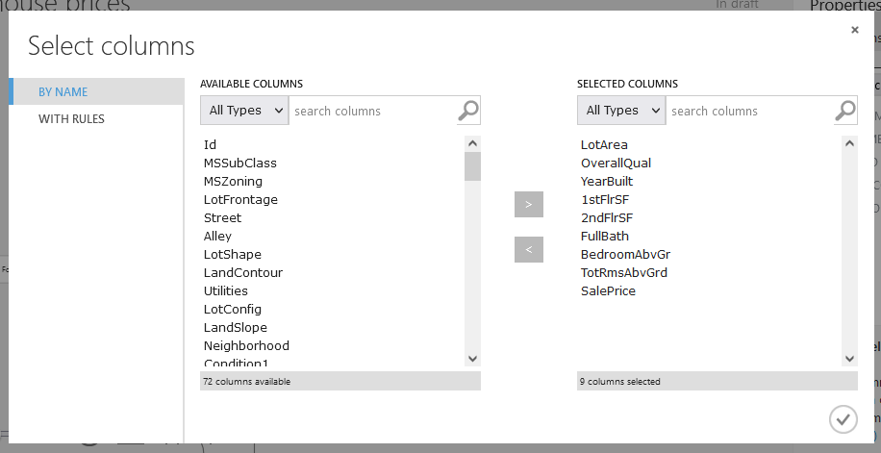

1. Clean Missing Data: Removing rows with missing data

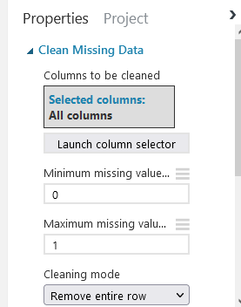

1. Split Data: Splitting data 75%-25%

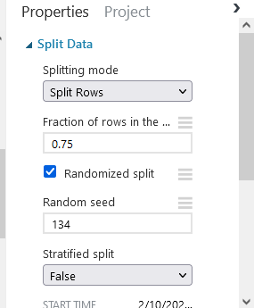

1. Training regression models
   1. Decision Forest Regressor
      1. 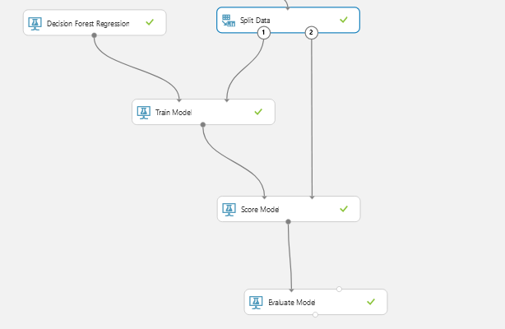
      2. Score:
         1. 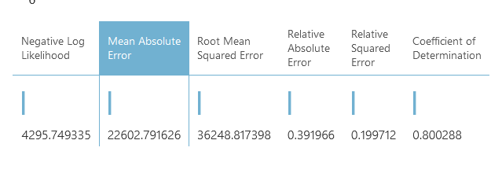
   2. Linear Regression Model
      1. 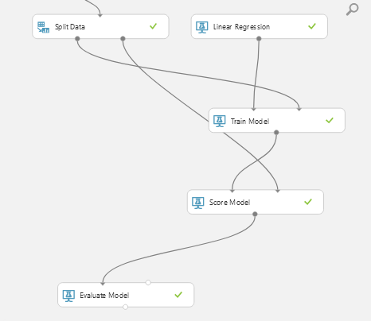
      2. Score
         1. 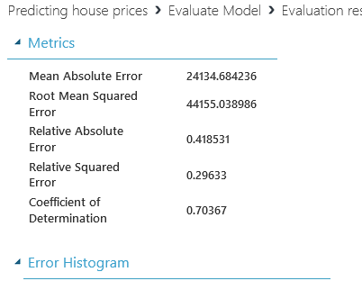\
   3. Neural Network Regression
      1. 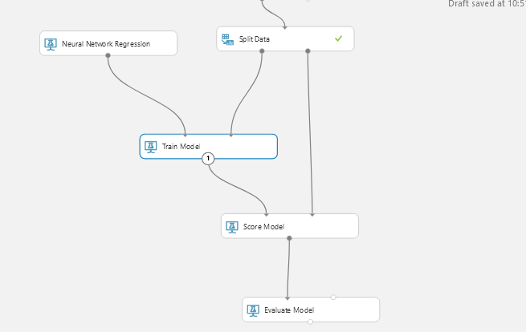
      2. Score:
         1. 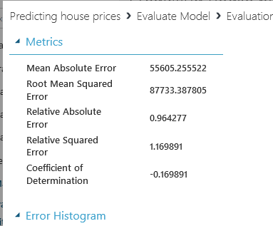

Out of the above chosen models; Decision Forest Regression, Linear Regression and Neural network regression model; **Decision Forest Regression** had the least Mean absolute error.